**Database-First approach**

**Using EF Core in a .NET Core Web Application**

***Note: When creating VS Project use the API Template to and delete the controllers***

**Install EF Core**

<https://www.entityframeworktutorial.net/efcore/install-entity-framework-core.aspx>

***Install EntityFramework.SqlServer through NuGet package manager***

***Install EntityFramework.Tools through NuGet package manager***

**Must be installed via the CLI**

<https://docs.microsoft.com/en-us/ef/core/miscellaneous/cli/dotnet#installing-the-tools>

dotnet tool install --global dotnet-ef

(installs EF Core to project from the root folder)

**Install DotNet Tools (Right click solution -> edit csproj file)**

<ItemGroup>

<PackageReference Include="Microsoft.EntityFrameworkCore.SqlServer" Version="3.1.4" />

<PackageReference Include="Microsoft.EntityFrameworkCore.Tools" Version="3.1.4">

<PrivateAssets>all</PrivateAssets>

<IncludeAssets>runtime; build; native; contentfiles; analyzers; buildtransitive</IncludeAssets>

</PackageReference>

<DotNetCliToolReference Include="Microsoft.EntityFrameworkCore.Tools.DotNet" Version="2.1.0-preview1-final" />

</ItemGroup>

**Create Scaffold-DbContext using Packet Manager Console**

Scaffold-DbContext "Server=.\SQLExpress;Database=(DBName);Trusted_Connection=True;" Microsoft.EntityFrameworkCore.SqlServer -OutputDir Models

Note: Must have a ‘Models’ folder to output to

Once the Models and DBContext class has been created we can create a Controllers folder -> Right-click on folder -> Add -> New Scaffolded Item -> API Controller with actions, using Entity Framework

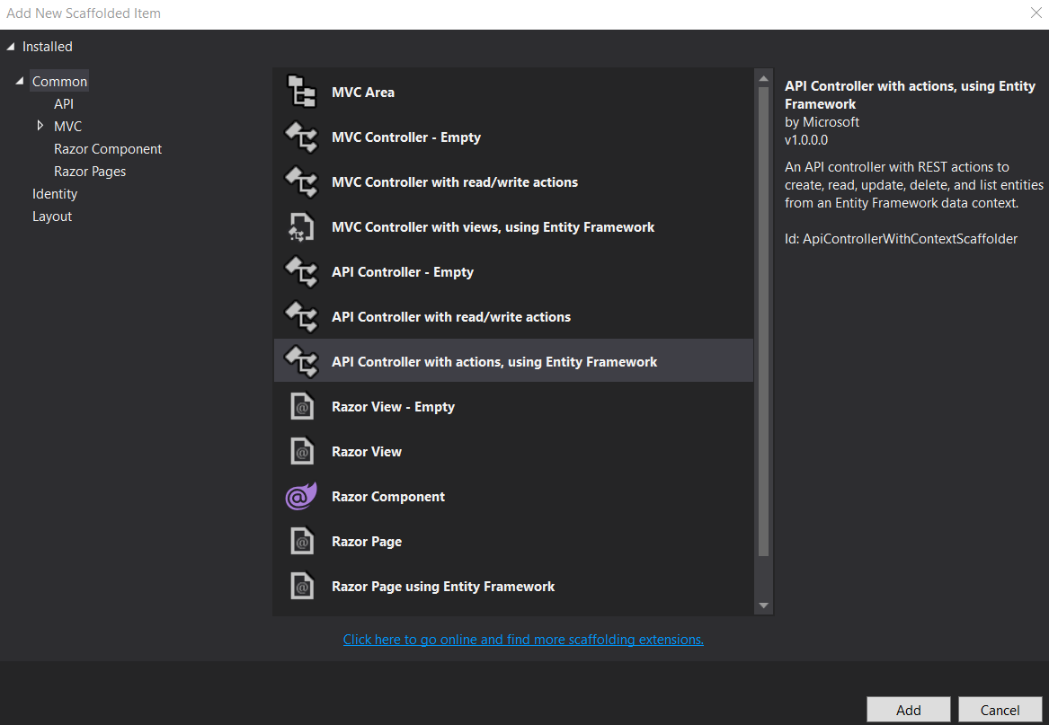

**Controller for the specified Model will be created**

**In the Startup.cs file add the following**

using Microsoft.EntityFrameworkCore;

using Diploma_DB_Task_API.Models;

(dependency injection to the class)

public void ConfigureServices(IServiceCollection services)

{

services.AddDbContext<(DBContextName)>(opt => opt.UseSqlServer("(Server_Name)"));

(Take connection string from DBContext)

}